Installation and User Guide of Personal Financial Butler (PFB)

# Part One: Installation

Step 1: Install relevant programs

* Python and a code editor is required. You can download and install the as follows:
  + Python –
    - https://www.python.org/downloads/ or
    - https://www.anaconda.com/products/distribution
  + Code editor (visual studio code)
    - <https://code.visualstudio.com/>

Step 2: Git clone repository and change file directory

* Git clone PFB Code from
  + <https://github.com/atsui888/Intelligent-Reasoning-Systems/tree/main/Code>

Step 3: Running Personal Financial Butler locally

* Clone or download the code files from GitHub (step 2 above)
* Navigate your way to the folder "Code"
  + if you chose the download zip file option, extract the files first!
* Create python virtual environment (optional)
  + conda create -n myenv python=3.8
  + activate the virtual environment you created
* Install:
  + conda install -c conda-forge pandas
  + conda install -c conda-forge statsmodels
  + conda install -c conda-forge asteval
  + pip install yfinance
  + pip install anvil-app-server
* Make sure you are at the folder 'Code' and **NOT** inside the folder 'ISS_IRS'
  + Run this command
    - 'anvil-app-server --app ISS_IRS'
* Open your web browser and key in "http://localhost:3030/" in the address bar.
* You should see the first screen of the 'Personal Financial Butler'.
* Have Fun!

# Part Two: User Guide

Step 1: Go to following url and you will see below screenshot : <https://bit.ly/3jQ0Df0>

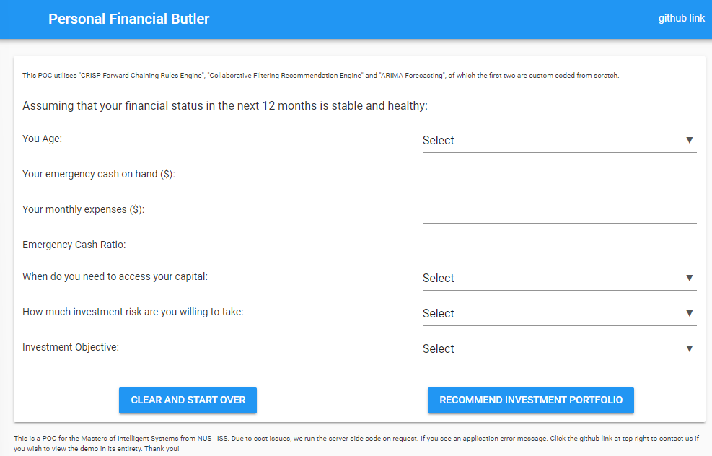

Step 2: Answer the questionnaire (see sample below).

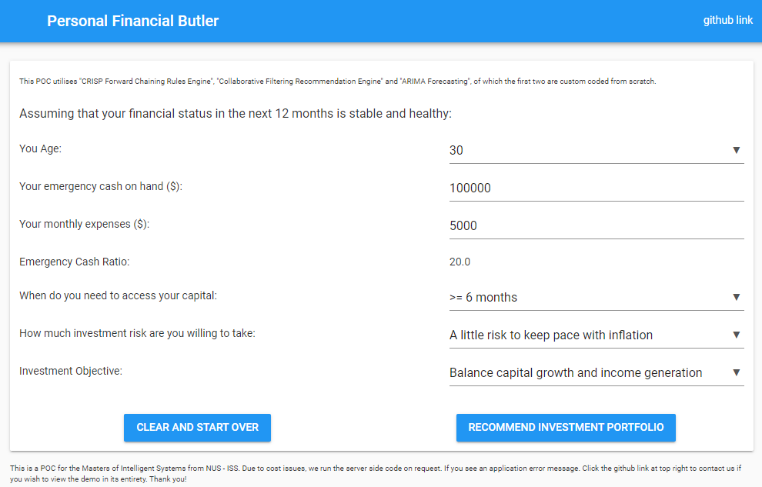

Step 3: Click “Recommend Investment Portfolio”

The PFB will then recommend a portfolio allocation between Stock and Bond as shown in screenshot. 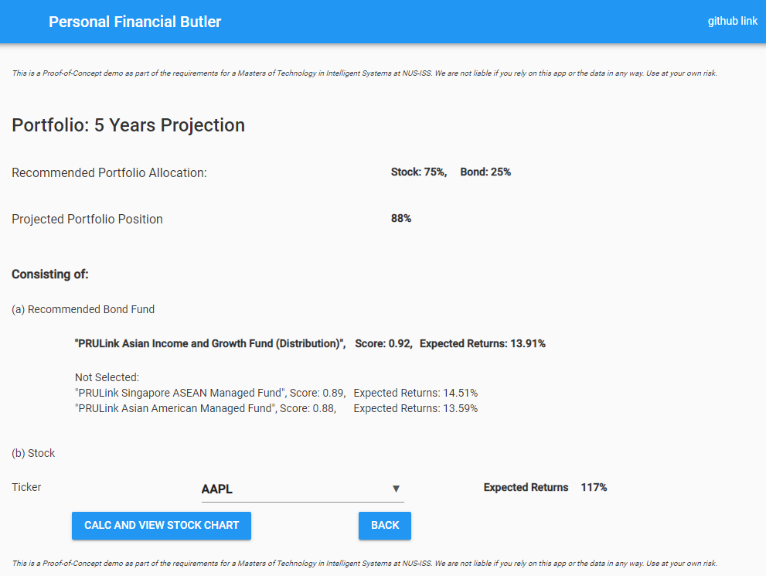

Step 4: Select the stock ticker from drop down button, and click “Calc and view stock chart”. This will return the share price projection.

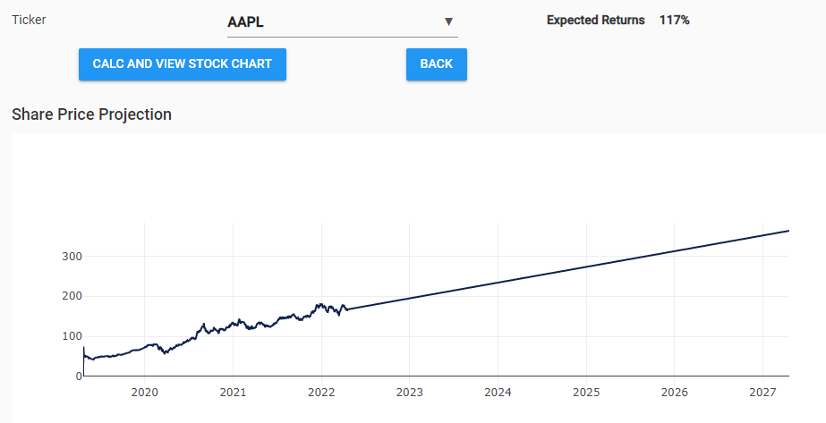

Step 5: Click “Back” to return to main page / first screen